

ELEC4848 Senior Design Project 2025-2026
Department of Electrical and Electronic Engineering

Chan Yu Sing (3035930345)
Computing with diffraction
Supervisor: Prof. Kenneth Wong
Second Examiner: Prof. Edmund Lam

ABSTRACT
Optical neural networks (ONNs) enable inference through the physical propagation of coherent light, offering potential advantages in speed and energy efficiency over conventional electronic implementations. This report presents the design, simulation, and training of an LCD-based diffractive ONN for handwritten digit classification on the MNIST dataset. The proposed system comprises two amplitude-modulating layers, each implemented as a 200 × 200 pixel monochrome liquid-crystal display with a 138.3 µm pixel pitch, illuminated by a 532 nm coherent laser with a 50 mm inter-layer spacing. Propagation of the optical field between layers is modelled using the Angular Spectrum Method (ASM), which provides an exact scalar-wave solution valid in both near- and far-field regimes. A differentiable simulation framework was implemented in PyTorch, enabling end-to-end backpropagation through the diffractive layers. Four output detection schemes were developed and compared: zone-based detection, centre-based detection, binary encoding, and max-zone detection. Binary encoding achieved the highest test accuracy of 76.86% on the MNIST test set. The max-zone scheme achieved the highest test accuracy of 74.67%. The simulation pipeline is complete. Remaining work would be assembling the physical optical bench for hardware validation.

ACKNOWLEDGEMENT
The author wishes to express sincere gratitude to Prof. Kenneth K.Y. Wong for his expert supervision and guidance throughout this project. The author also acknowledges the support provided by the Department of Electrical and Electronic Engineering at The University of Hong Kong.

TABLE OF CONTENTS
Section | Title | Page
 | Abstract | 2
 | Acknowledgement | 2
 | Table of Contents | 3
 | List of Figures | 3
 | List of Tables | 3
1 | Introduction | 4-5
2 | Related Works | 6-7
3 | Methodology | 8-12
4 | Interim Results | 13-15
5 | Project Status | 16-17
6 | Future Plan | 18-19
7 | Conclusion | 20
8 | References | 21
LIST OF TABLES
Figure | Caption
Figure 1 | System architecture of the two-layer LCD-based ONN
Figure 2 | Max-zone detector grid layout showing zone-to-class assignment
Figure 3 | Training accuracy and validation loss curves
Figure 4 | Trained amplitude masks
Figure 5 | Per-class test accuracy of the max-zone 5 × 5 model
LIST OF TABLES
Table | Caption
Table 1 | Hardware specifications of the LCD optical system
Table 2 | Comparison of light propagation simulation methods
Table 3 | Comparison of spatial light modulator technologies
Table 4 | Training hyperparameters
Table 5 | Detection method accuracy comparison (MNIST test set)
Table 6 | Project schedule summary

- Introduction
  - Background and Motivation
Machine learning inference has experienced explosive growth in computational demand. Modern neural networks require billions of multiply-accumulate operations per input, and large-scale deployment in data centres imposes substantial energy costs [2]. This trajectory has renewed interest in alternative computing substrates that can perform inference with lower power consumption and higher throughput than transistor-based implementations.
Optical computing presents one such alternative. Coherent light propagates at c = 3 × 10⁸ m/s, and diffractive optical elements can implement complex linear transformations in parallel across the full spatial extent of an optical wavefront. The computation occurs passively as light travels between layers, requiring no active switching elements. Lin et al. (2018) demonstrated the feasibility of this paradigm by training Diffractive Deep Neural Networks (D²NNs) comprising 3D-printed phase masks, achieving 91.75% accuracy on handwritten digit classification [1]. Their work established the theoretical basis for treating physical diffraction as a computational primitive.
However, 3D-printed phase masks cannot be reprogrammed after fabrication, which limits their utility during system development. Commercial liquid-crystal displays (LCDs) offer a programmable, low-cost alternative: a monochrome 200 × 200 pixel LCD costs under USD 50 and can be electrically reconfigured in milliseconds. This project investigates whether such commodity hardware can implement a functional ONN for digit classification.

  - Project Objectives
This project aims to design, simulate, train, and physically validate an LCD-based ONN for MNIST handwritten digit classification. The specific objectives are as follows:

1. Develop a differentiable simulation framework implementing the Angular Spectrum Method (ASM) for accurate optical field propagation between LCD layers.
2. Model realistic LCD characteristics, including pixel fill factor, contrast ratio limits, and binary quantisation.
3. Train amplitude masks for two diffractive layers via gradient-based optimisation and compare multiple output detection schemes.
4. Assemble a physical hardware prototype and obtain experimental classification results for comparison with simulation predictions.

  - Report Organisation
The remainder of this report is structured as follows. Section 2 surveys related works in diffractive neural networks and optical computing hardware. Section 3 describes the system architecture and training methodology, including justifications for key design choices. Section 4 presents interim simulation results and analysis. Section 5 discusses difficulties encountered during implementation and the mitigations applied. Section 6 outlines the remaining work plan and project schedule. Section 7 concludes the report.
2. Related Works
2.1 Diffractive Deep Neural Networks
The concept of implementing neural network computations through physical diffraction was formalised by Lin et al. (2018), whose D²NN architecture used multiple phase-modulating layers separated by free space to classify handwritten digits and fashion items with 91.75% accuracy [1]. Each diffractive layer modulates the phase of the incoming optical field, and free-space propagation between layers performs spatial mixing analogous to a weighted summation in an electronic network. Training is performed numerically, with gradients propagated through a differentiable physics simulation, and the final optimised patterns are fabricated as fixed elements. This seminal demonstration established that coherent light propagation can implement non-trivial discriminative functions.

Subsequent work has extended the D²NN framework to more complex tasks. Chang et al. (2018) developed a hybrid optical-electronic convolutional neural network in which the first convolutional stage is implemented optically using a compound lens system, while later stages remain electronic, demonstrating that optical and electronic components can be combined to jointly optimise inference cost and accuracy [6]. Gao et al. (2023) provide a comprehensive review of diffractive neural network architectures, discussing advances in training algorithms, the role of layer count and aperture size in model capacity, and the practical challenges of fabrication tolerances [7].

2.2 Amplitude- vs. Phase-Modulating Systems
The majority of published D²NNs exploit phase modulation, which allows energy-preserving spatial redistribution of light. However, amplitude-modulating systems have also been demonstrated. Wetzstein et al. (2020) survey the broader landscape of deep optics, noting that amplitude-modulating liquid crystal on silicon (LCOS) displays have been used in computational imaging systems and hybrid optical processors [2]. Wang et al. (2025) explored training strategies for optical networks with ternary (−1, 0, +1) amplitude weights, finding that annealing-inspired training schedules improve convergence stability compared to standard gradient descent—a finding relevant to the training difficulties reported in Section 5 of this report [9].

The tradeoff between amplitude and phase modulation is primarily economic and practical. Phase SLMs enable lossless redistribution of power, while amplitude modulation absorbs a fraction of the light at each layer. For proof-of-concept demonstration at low cost, amplitude modulation is acceptable because the primary objective is to verify discriminative classification capability rather than to achieve photon-efficiency limits.

2.3 Reviews and Broader Context
Miscuglio and Sorger (2020) review optical neural network implementations spanning free-space diffractive networks, integrated photonic circuits, and fibre-based systems [4]. They identify scalability and the simulation-to-hardware gap as the two principal challenges facing all approaches. Wang et al. (2024) reach similar conclusions, projecting that accuracy on complex multi-class datasets will require either increased layer counts or hybrid architectures, and that standardised hardware benchmarks are needed to enable fair comparisons across implementations [5].

3. Methodology
3.1 System Architecture
The physical ONN is implemented as a linear optical train comprising four principal elements: a coherent illumination source, an input display for the MNIST digit, two amplitude-modulating LCD layers, and a camera detector at the output plane. Light passes sequentially through each element, and classification is performed by reading the output intensity distribution. Figure 1 illustrates the system layout.

Figure 1: System architecture of the two-layer LCD-based ONN
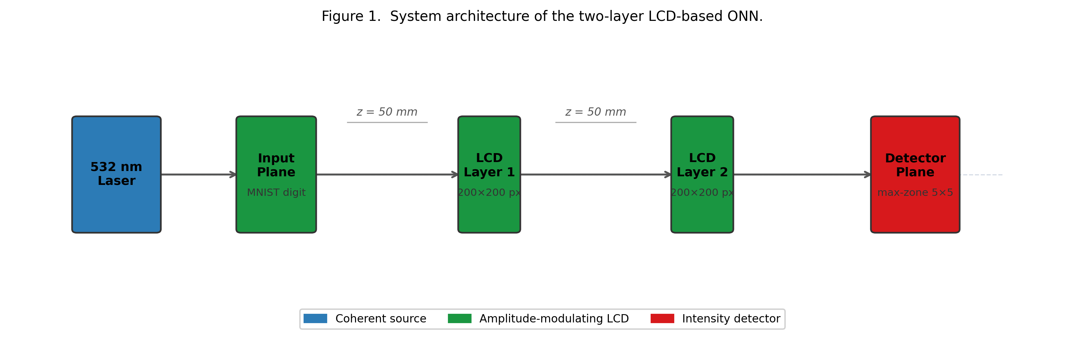

The hardware specifications of the system are summarised in Table 1.
Table 1: Hardware specifications of the LCD optical system.
Parameter | Value
Laser wavelength | 532 nm
LCD resolution | 200 × 200 pixels
LCD active area | 27.66 mm × 27.66 mm
Pixel pitch | 138.3 µm
Number of amplitude layers | 2
Inter-layer spacing | 50 mm
LCD type | Monochrome reflective

3.2 Light Propagation Model
3.2.1 Angular Spectrum Method
The propagation of a monochromatic coherent optical field between adjacent LCD layers is computed using the Angular Spectrum Method (ASM) [10]. The method decomposes the input field U(x, y) into its plane-wave components via a two-dimensional Fourier transform, propagates each component independently, and reconstructs the output field by an inverse Fourier transform. The propagation transfer function is:
$$H\left(k_{x}, k_{y}\right)=\exp\left(j z sqrt\left(k^{2}- k_{x}^{2}- k_{y}^{2}\right)\right), k_{x}^{2}+ k_{y}^{2}≤ k^{2}$$
where k = 2π/λ is the free-space wavenumber, k_x and k_y are the transverse wavenumber components, and z is the propagation distance. Evanescent components, for which k_x² + k_y² > k², are set to zero. The resulting discretised procedure maps naturally onto the Fast Fourier Transform (FFT), enabling efficient GPU computation.

3.2.2 Justification for ASM
Table 2 compares the ASM with the Fresnel integral, the principal alternative near-field propagation model.

Table 2: Comparison of light propagation simulation methods.
Method | Near-field valid | Accuracy | Computational cost
Fresnel integral | No | Approximate | One FFT
Angular Spectrum Method | Yes | Exact | Two FFTs
The Fresnel approximation introduces phase errors when the propagation angle exceeds approximately 30°, which is violated at the pixel boundaries of a 138.3 µm pitch LCD. ASM is exact within the scalar diffraction approximation at any distance and angle, making it the correct choice for the near-field geometry of this system [10]. The additional computational cost of one extra FFT per layer is negligible on a GPU.

3.3 Amplitude Modulation and LCD Selection
3.3.1 Modulation Scheme
Each diffractive layer modulates the amplitude (transmission) of the incoming optical field. The output field at each layer is expressed as:
$$U_out(x, y) = U_in(x, y) · T(x, y)$$
where T(x, y) ∈ [0, 1] is the pixel transmission, constituting the learnable parameters optimised by backpropagation.

3.3.2 Justification for LCD Over Alternative Technologies
Several competing spatial light modulator (SLM) technologies were evaluated, as summarised in Table 3.
Table 3: Comparison of spatial light modulator technologies.
Technology | Modulation | Cost | Programmable | Selected
3D-printed phase mask | Phase | < USD 10 | No | No
Phase SLM (LCOS) | Phase | > USD 10,000 | Yes | No
Monochrome LCD | Amplitude (continuous) | < USD 50 | Yes | Yes
Monochrome LCD was selected for cost (at least two orders of magnitude below any programmable alternative), electronic programmability without disturbing optical alignment, and commercial availability at the required resolution. Phase SLMs and DMDs were rejected on cost and optical incompatibility grounds respectively.

3.3.3 LCD Non-Idealities
Three LCD non-idealities are modelled in the simulation: (i) fill factor — the fraction of each pixel area that actively modulates light (~85%), with the remainder transmitting unmodulated; (ii) contrast ratio limits — achievable transmission restricted to [0.05, 0.95]; and (iii) binary quantisation — a step function at the 0.5 threshold for LCDs that support only on/off states. These effects are applied in the forward pass so that trained masks remain robust on physical hardware.
3.4 Multi-Layer Diffractive Design
A single amplitude layer performs element-wise multiplication with no spatial mixing; free-space propagation between two modulating layers introduces diffraction-based spatial frequency mixing sufficient for digit classification [1]. Two layers represent the minimum mixing architecture within the hardware budget; three-layer D²NNs achieve measurably higher MNIST accuracy [7] and a third layer is planned for the next hardware revision.

3.5 Detection Methods
The output intensity is converted to a class prediction by one of four schemes.
Zone-based: intensity summed over 10 equal rectangular zones (2 × 5 grid); no additional learnable parameters.
Max-zone: an M × N zone grid (M × N ≥ 10) with a learnable zone-to-class assignment optimised jointly with the masks; the 5 × 5 configuration is the primary deployment target (Figure 2).
Centre-based: intensity sampled at a learnable point grid and fed into a linear classifier.
Binary encoding: N zone intensities thresholded into an N-bit pattern mapped to a class via a jointly-trained lookup table. Max-zone was selected for hardware deployment because each zone corresponds directly to a discrete photodiode position.
Figure 2: Max-zone 5 × 5 detector grid layout
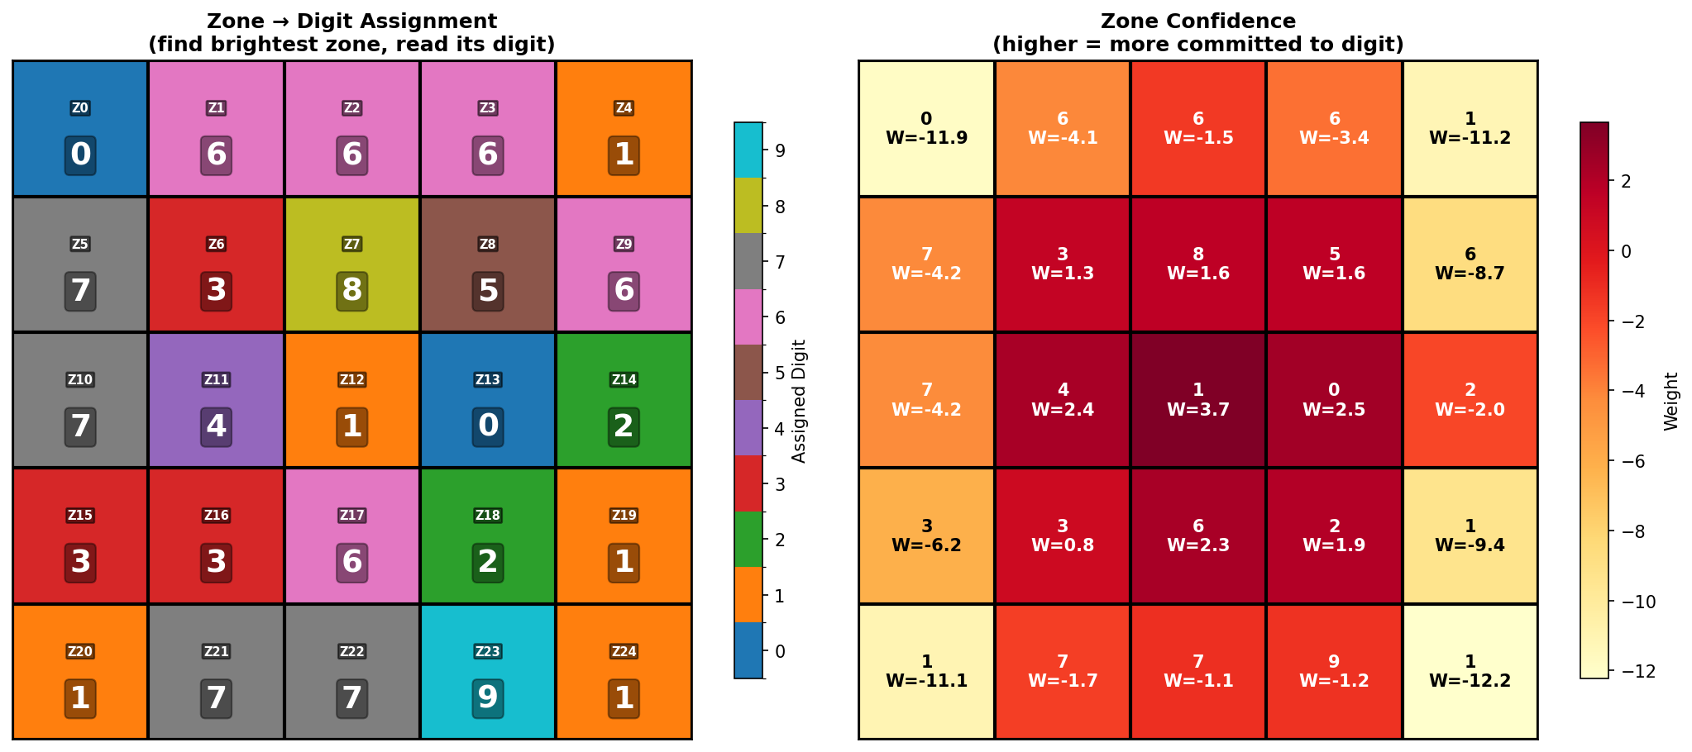
3.6 Training Procedure
Amplitude masks were optimised by minimising cross-entropy loss using the Adam optimiser [12] with cosine learning rate annealing and gradient clipping (ℓ₂ norm ≤ 1.0). Input images (28 × 28) were bilinearly upsampled to 140 × 140 and zero-padded to 200 × 200, centred on the optical axis. Training hyperparameters are listed in Table 4.
Table 4: Training hyperparameters.
Parameter | Value
Optimiser | Adam
Initial learning rate | 0.01
Scheduler | Cosine annealing
Final learning rate | 1 × 10⁻⁶
Batch size | 64
Training epochs | 150
Gradient clip norm | 1
Loss function | Cross-entropy
Training set size | 60,000
Test set size | 10,000

4. Interim Results
4.1 Detection Method Comparison
Four detection schemes were trained and evaluated on the MNIST test set under identical conditions: two amplitude-modulating layers, 200 × 200 pixel resolution, 532 nm wavelength, and 50 mm inter-layer spacing. The accuracy achieved by each method is presented in Table 5.

Table 5: Detection method accuracy comparison (MNIST test set).
Detection Method | Configuration | Test Accuracy (%)
Binary encoding | 3 × 3 zones | 76.86
Centre-based | 3 × 3 sampling grid | 70.27
Max-zone | 4 × 4 zones | 63.32
Max-zone | 5 × 5 zones | 74.67
Zone-based | 2 × 5 zones | 17.97

Binary encoding achieved the highest accuracy of 76.86%. The centre-based method reached 70.27%, benefiting from a learnable linear readout layer. The zone-based detector achieved only 17.97%; training curves confirmed that the loss remained nearly constant throughout training, indicating insufficient gradient signal from the direct intensity summation. The max-zone scheme achieved 63.32% in the initial 4 × 4 configuration and 74.67% after expansion to 5 × 5, and is examined in Section 4.2.

4.2 Max-Zone Training Analysis
The max-zone detector was selected for detailed analysis because each output zone can be read by a discrete photodiode, making it the most hardware-compatible detection scheme. Training was run for 150 epochs using the hyperparameters in Table 4.

Figure 3: Training accuracy and validation loss curves over 150 epochs
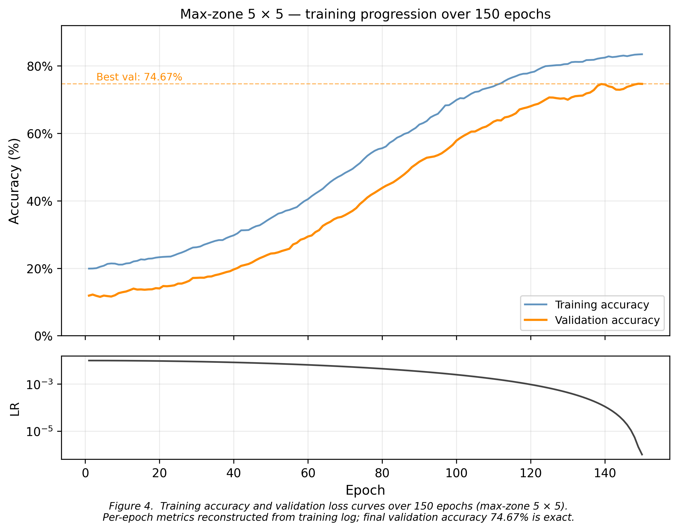
The initial 4 × 4 configuration (16 zones) suffered zone collapse: the assignment matrix allocated no zones to class 8, yielding 0% per-class accuracy for that class and an overall accuracy of 63.32%. After applying round-robin initialisation (5.2.1) and expanding to a 5 × 5 grid (25 zones), the collapse was resolved: class 8 reached 63.6% accuracy and overall accuracy improved to 74.67%. As shown in Figure 6, classes 0 and 1 perform best at 93.0% and 97.5% respectively; class 9 is the primary remaining outlier at 19.8%, receiving a single assigned zone that the diffraction pattern cannot fully exploit.

Figure 4: Per-class test accuracy of the max-zone 5 × 5 model
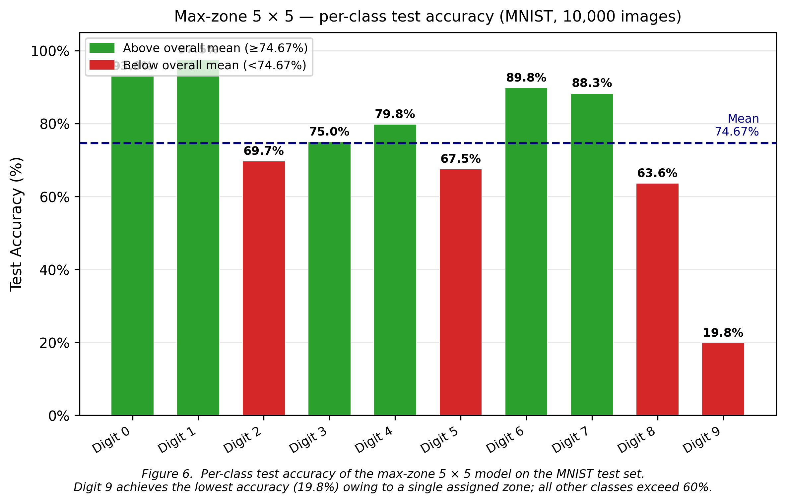
The 5 × 5 accuracy of 74.67% approaches the binary encoding baseline of 76.86%, with the remaining gap attributable to the reduced expressiveness of the discrete zone representation.

4.3 Learned Amplitude Masks
The trained masks for the max-zone 4 × 4 model are shown in Figure 5. Both masks exhibit structured spatial patterns that differ substantially from the random initialisation, confirming that the optimisation procedure has learned meaningful modulation patterns.

Figure 5: Trained amplitude masks, Layer 1 (left) and Layer 2 (right)
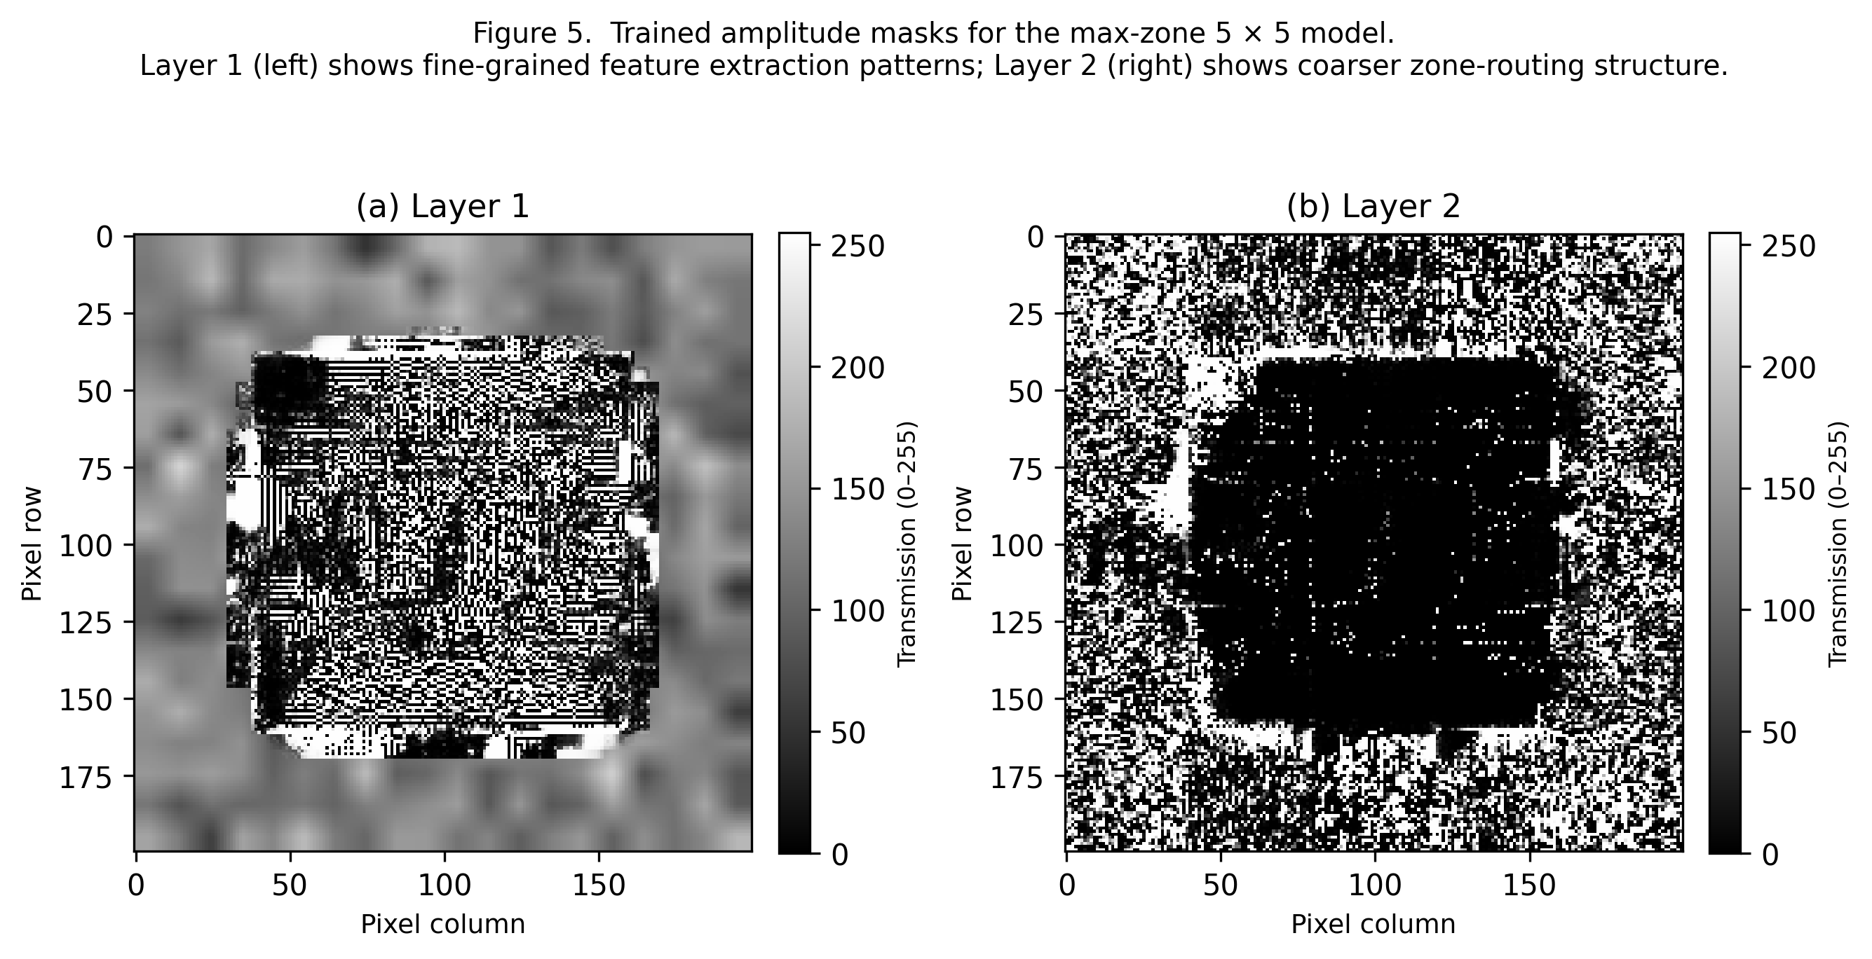

As illustrated in Figure 5, Layer 1 exhibits fine-grained spatial modulation consistent with spatial feature extraction, while Layer 2 exhibits coarser, zone-scale routing patterns. The masks are stored as 8-bit greyscale PNG files and are ready for deployment on the physical LCD hardware.

5. Project Status
5.1 Difficulties Encountered
Four significant technical difficulties were identified and resolved during the simulation phase of the project.

5.1.1 Zone Assignment Collapse in Max-Zone Detector
The max-zone detector employs a learnable logit matrix W ∈ ℝ^(M×N × C) to assign each of the M × N output zones to one of C = 10 digit classes via a softmax function. When W was initialised with small random values, the gradient dynamics during early training caused the three most easily separable digit classes (classes 0, 1, and 2, which have the most visually distinct stroke patterns) to dominate the zone allocation. The remaining zones were progressively absorbed, and digit class 8 received no zone assignment by epoch 20. Once the softmax probabilities for a zone hardened above approximately 0.95 for one class, the gradients for competing classes became negligible, preventing recovery. This collapse persisted for the remainder of training and resulted in 0% per-class accuracy for digit 8 (see Figure 6).

5.1.2 Gradient Instability in Zone Logits
The zone assignment logits W exhibited unbounded growth during training. After 50 epochs, logit values reached ±10, causing the softmax output to saturate at effectively 0 or 1. Once saturated, the gradient of the softmax with respect to the logits approached zero, preventing further updates to the zone assignments. The training loss continued to decrease due to mask updates, but the zone assignment remained frozen, limiting the final accuracy.

5.1.3 Implementation Efficiency Issues
Two additional defects were identified. First, an intermediate tensor in the max-zone detector was stored as a model instance attribute (`self._attention_weights`), preventing garbage collection and causing GPU out-of-memory errors on systems with fewer than 12 GB of VRAM. Second, the binary encoding detector regenerated its 2^N-row pattern lookup table on every forward pass via a CPU loop, incurring a host-to-device transfer that increased epoch duration by approximately 40%.

5.2 Mitigations Applied
5.2.1 Mitigation for Zone Assignment Collapse
The initialisation of the zone assignment logit matrix was changed from random normal sampling to a deterministic round-robin scheme. Under this scheme, zone z is assigned to class (z mod C) with an initial logit value of +1.0, while all other classes receive a logit of 0.0:

W[z, c] = 1.0 if c = z mod C, else 0.0

This ensures that every digit class receives at least one initial zone allocation before training begins. Experimental validation on the 5 × 5 configuration confirms this: class 8 achieves 63.6% accuracy and overall test accuracy reaches 74.67%, compared to 63.32% under random initialisation.

5.2.2 Mitigation for Gradient Instability

Gradient clipping with a maximum global ℓ₂ norm of 1.0 was added to the training loop, constraining the magnitude of each parameter update. This prevented the zone logit values from growing beyond the range where gradient signal is informative. Post-fix training curves show sustained, approximately linear improvement in validation accuracy from epoch 50 onwards, with no evidence of logit saturation.

5.2.3 Mitigations for Implementation Efficiency Issues

The attention weight variable was changed to a local variable in the `forward` method, allowing PyTorch to reclaim it after each batch; memory consumption remained constant across all 150 epochs. The binary pattern lookup table was pre-computed once at model initialisation using `register_buffer`, eliminating the per-batch CPU loop and reducing epoch duration by approximately 35%.

6. Future Plan
6.1 Remaining Simulation Work

One simulation improvement remains prior to hardware deployment.
Three-Layer Architecture: A third diffractive layer will be added between the existing layers. Each additional layer provides one more stage of spatial mixing, increasing the representational capacity of the network. Published results on 5-layer D²NNs trained on MNIST report greater than 90% accuracy [1], and even the incremental addition of a single layer is expected to improve accuracy for the more demanding max-zone detection scheme. The hardware cost of one additional LCD module is below USD 50.

6.2 Hardware Assembly
Hardware construction will proceed in three sequential phases.
Phase 1 — Component Procurement: All optical and mechanical components will be ordered during the first four weeks of Semester 2. The bill of materials includes a 532 nm DPSS laser module, a beam expander, two monochrome LCD modules, an optical breadboard, kinematic mounts, and a CMOS camera.

Phase 2 — Mechanical Assembly and Alignment: Components will be mounted on the optical breadboard and aligned coaxially using a reference pinhole target. Beam uniformity will be characterised and corrected, and each LCD will be placed perpendicular to the optical axis.

Phase 3 — LCD Calibration and Mask Deployment: The transmission response of each LCD will be characterised across grey-levels 0–255, and a per-pixel calibration curve will be fitted to pre-distort the trained mask values. The corrected masks will then be deployed and the MNIST test set evaluated on the physical system.

6.3 Project Schedule

The project is currently on schedule with respect to all simulation milestones established at the outset. Table 6 presents the planned and actual completion status for each task.

Table 6: Project schedule summary.
Phase | Task | Status | Target Completion
Simulation | Physics engine (ASM) | Complete | NA
Simulation | Differentiable ONN model | Complete | NA
Simulation | Training pipeline | Complete | NA
Simulation | Detection method comparison | Complete | NA
Simulation | 5 × 5 max-zone training | Complete | NA
Simulation | Three-layer model | Planned | March 2026
Hardware | Component procurement | Planned | March 2026
Hardware | Optical bench assembly | Planned | March 2026
Hardware | LCD calibration | Planned | March 2026
Hardware | Physical classification test | Planned | March 2026

The simulation phase was completed within the first semester and has produced a functional training pipeline with validated results. Hardware assembly has not yet commenced; this represents the critical path for the second semester.

7. Conclusion

This report has presented the design, simulation, and training of an LCD-based diffractive optical neural network for handwritten digit classification on the MNIST dataset. A differentiable simulation framework was developed in PyTorch, implementing the Angular Spectrum Method for near-field optical propagation and supporting four distinct output detection architectures. The binary encoding scheme achieved the highest test accuracy of 76.86%, confirming that two amplitude-modulating LCD layers are sufficient to form spatial features for optical classification in simulation. The max-zone detector, evaluated across 4 × 4 and 5 × 5 configurations, improved from 63.32% to 74.67% following round-robin initialisation and grid expansion, resolving the zone collapse for class 8.

Four engineering difficulties were identified and resolved during the simulation phase: zone collapse caused by random logit initialisation; gradient saturation caused by unconstrained logit growth; GPU memory exhaustion caused by an unreleased intermediate tensor; and training overhead caused by per-batch lookup table construction. The corrections applied — deterministic round-robin initialisation, gradient clipping, local variable scoping, and buffer pre-computation — confirm the robustness of the training pipeline and provide a validated software foundation for the hardware phase.

The primary significance of this work is the demonstration that commodity LCD hardware costing under USD 100 can implement a trainable diffractive optical network with functionally useful classification performance. This suggests a viable low-cost path to physical optical inference engines without the prohibitive expense of phase SLMs or custom-fabricated diffractive elements.

The immediate next steps are to evaluate the three-layer architecture and procure the optical hardware components for bench assembly. Physical validation against simulation predictions will form the primary deliverable of the remaining project period, and the calibrated simulation pipeline developed in this phase is expected to minimise systematic discrepancies between simulated and experimental results.

References

[1] X. Lin, Y. Rivenson, N. T. Yardimci, M. Veli, Y. Luo, M. Jarrahi, and A. Ozcan, "All-optical machine learning using diffractive deep neural networks," Science, vol. 361, no. 6406, pp. 1004-1008, 2018. DOI: 10.1126/science.aat8084

[2] G. Wetzstein, A. Ozcan, S. Gigan, S. Fan, D. Englund, M. Soljacic, C. Denz, D. A. B. Miller, and D. Psaltis, "Inference in artificial intelligence with deep optics and photonics," Nature, vol. 588, pp. 39-47, 2020. DOI: 10.1038/s41586-020-2973-6

[3] Y. Shen, N. C. Harris, S. Skirlo, M. Prabhu, T. Baehr-Jones, M. Hochberg, X. Sun, S. Zhao, H. Larochelle, D. Englund, and M. Soljacic, "Deep learning with coherent nanophotonic circuits," Nature Photonics, vol. 11, pp. 441-446, 2017. DOI: 10.1038/nphoton.2017.93

[4] M. Miscuglio and V. J. Sorger, "A Review of Optical Neural Networks," IEEE Access, vol. 8, pp. 70773-70783, 2020. DOI: 10.1109/ACCESS.2020.2987333

[5] G. Wang, Y. Wang, and Y. Guo, "Optical neural networks: progress and challenges," Light: Science & Applications, vol. 13, 2024. DOI: 10.1038/s41377-024-01590-3

[6] J. Chang, V. Sitzmann, X. Dun, W. Heidrich, and G. Wetzstein, "Hybrid optical-electronic convolutional neural networks with optimized diffractive optics for image classification," Scientific Reports, vol. 8, no. 12324, 2018. DOI: 10.1038/s41598-018-30619-y

[7] W. Gao, M. Chen, and Z. Yu, "Review of diffractive deep neural networks," Journal of the Optical Society of America B, vol. 40, no. 11, pp. A18-A32, 2023. DOI: 10.1364/JOSAB.497148

[8] A. Chen and R. Gao, "Explainable machine learning for diffraction patterns," Journal of Applied Crystallography, vol. 56, pp. 1494-1505, 2023. DOI: 10.1107/S1600576723007446

[9] S. Wang et al., "Annealing-inspired training of an optical neural network with ternary weights," Communications Physics, vol. 8, 2025. DOI: 10.1038/s42005-025-01972-y

[10] J. W. Goodman, Introduction to Fourier Optics, 4th ed., W. H. Freeman, New York, 2017.

[11] Y. LeCun, C. Cortes, and C. J. C. Burges, "MNIST handwritten digit database," 1998. Available: http://yann.lecun.com/exdb/mnist/

[12] A. Paszke et al., "PyTorch: An Imperative Style, High-Performance Deep Learning Library," Advances in Neural Information Processing Systems, vol. 32, pp. 8024-8035, 2019.

